Hello OVAHC,
We are publishing this notice in the January and February Newsleak especially for those without email addresses in our club. Please, everyone look around for new items to buy.
We have a plan for those of you who want to buy 2020 club shirts, etc. Jake Jacobs has a guy who will make them for us at a reasonable price. We won't use club funds or try to mark them up, either. You will order them in person, via email, or by phone, and the final order will be placed after the February OVAHC meeting. Catalogues will be there. We will have an order sheet if you are ready to order. The small club logo will be on the left breast area, or on the front of the caps. Pay when you pick them up beginning at the March meeting. No mail orders, please.
Feel free to check out the web version and we need the brand, item number, size, and color for each one you are buying. Final pricing will be as close to the catalogue as possible. Payments go to Jake Jacobs since he is pre-paying for all of them. However, since he is a super busy guy, respond to me at dlb55ah@cs.com with your order. My phone number is 859-384-1345 if you need to order by phone or have questions. All sales final, please.OVAHC Secretary, Dale
This first web site has prices, but it will be a little extra for the logo
http://www.espinc.norwood.com/category/APPAREL/Apparel/ 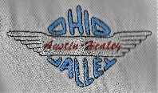
The following web site has no prices, would have to check on each item. They would be almost the same as the other site. Some brands are lower in price.
WEB SITE FOR APPAREL: www.companycasuals.com/excel
for hats : https://www.companycasuals.com/EXCEL/b.jsp?id=7794703&ln=126-7794703
Port Authority® stretch pique Polo. 55cotton/40poly/5spandex about $25 each
Stretch your wardrobe options with this breathable, moisture-wicking polo that features a touch of spandex for easy movement. Clean-finished details give this polo an upscale look, while our finishing wash adds extra softness. Adult Sizes: XS-4XL For XXL and above add >$2. Final pricing is flexible.
Ladies L555 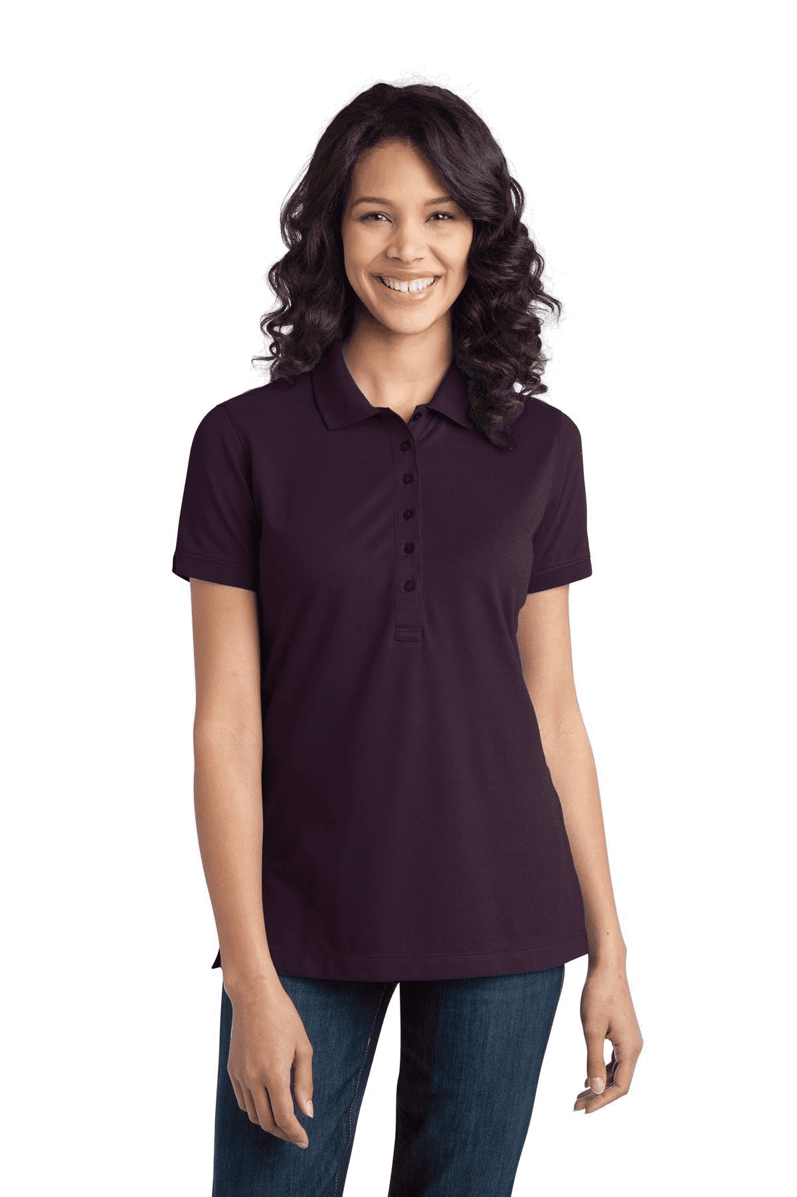 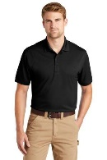
Aubergine Purple PMS 7449C and in all mens colors below, too including WHITE
Mens K555
Black Chili Red 202 Dress Blue Navy533 Grey Smoke426 Moonlight Blue7684 and

